University POLITEHNICA of Bucharest

Faculty of Electronics, Telecommunications, and Information Technology

Negative Voltage Regulator

Student: Coordinator(s):

Pop Mihai-Octavian Teodorescu Laurentiu

Group:431F

Year:2023

1. **Project requirements (1 page)**

It is required to design a circuit with the following parameters:

Negative supply voltage between -30 ÷ -27 [V];

Negative programmable output voltage between – 23 ÷ 22 [V];

The output current through the load between 0 ÷ 30 [mA];

Short circuit protection of the output terminals with foldback current limiting circuit.

 40.

The output impedance of the regulator3 Ω

1. **The block diagram of the circuit (1-2 pages)**

Here will be a block diagram of the circuit designed by you. The role of each sub-block present on the diagram will be explained in writing.

Mirror

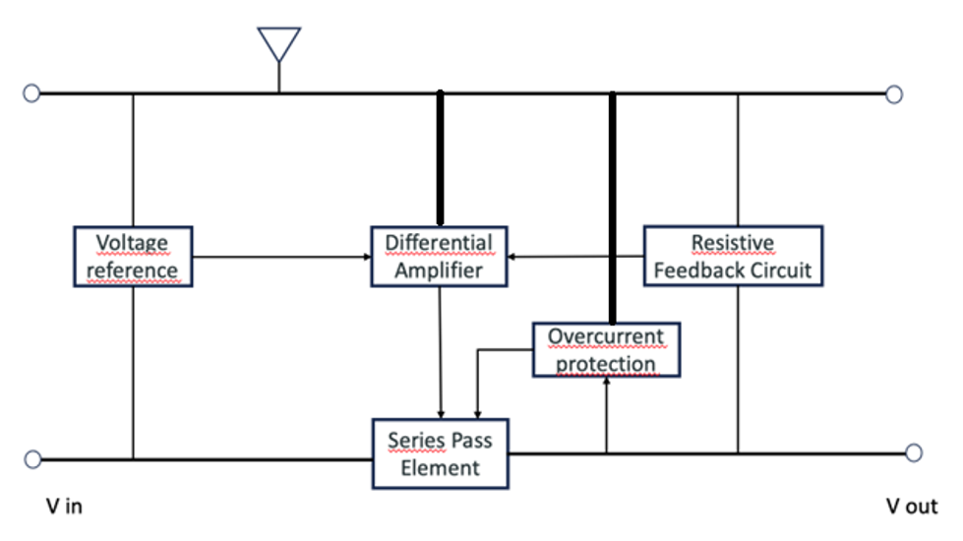

**Explanation:**

Voltage Reference (Vref): Employing a Zener diode in this circuit segment will stabilize the input voltage under varying conditions such as load fluctuations, changes in power supply voltage, and temperature shifts.

Series Pass Element (ERS): Directing current with a specific gain towards the output, a transistor serves as the series pass element.

Differential/Error Amplifier (AD): Utilizing a non-inverting amplifier, this section takes the reference voltage from above on the non-inverting input and a fraction of the stabilized voltage on the inverting input. With high open-loop amplification, the potentials of both inputs remain equal.

Overcurrent Protection (CP): The straightforward overcurrent protection restricts the output voltage and current linearly during overload, safeguarding the ERS and ensuring healthy power dissipation.

Resistive Feedback Circuit (RR): Tasked with controlling and maintaining the output voltage, this negative feedback network receives a portion of the output signal and feeds it back into the AD. The output voltage value is dependent solely on the passive components' values and the reference voltage through the negative feedback network, requiring a potentiometer for adjustments.

3. **The detailed schematic diagram with detailed explanations related to operation, identification of each sub-block which was presented in the block diagram, and the calculations for each component (passive or active) that is part of that sub-block (5-10 pages).**

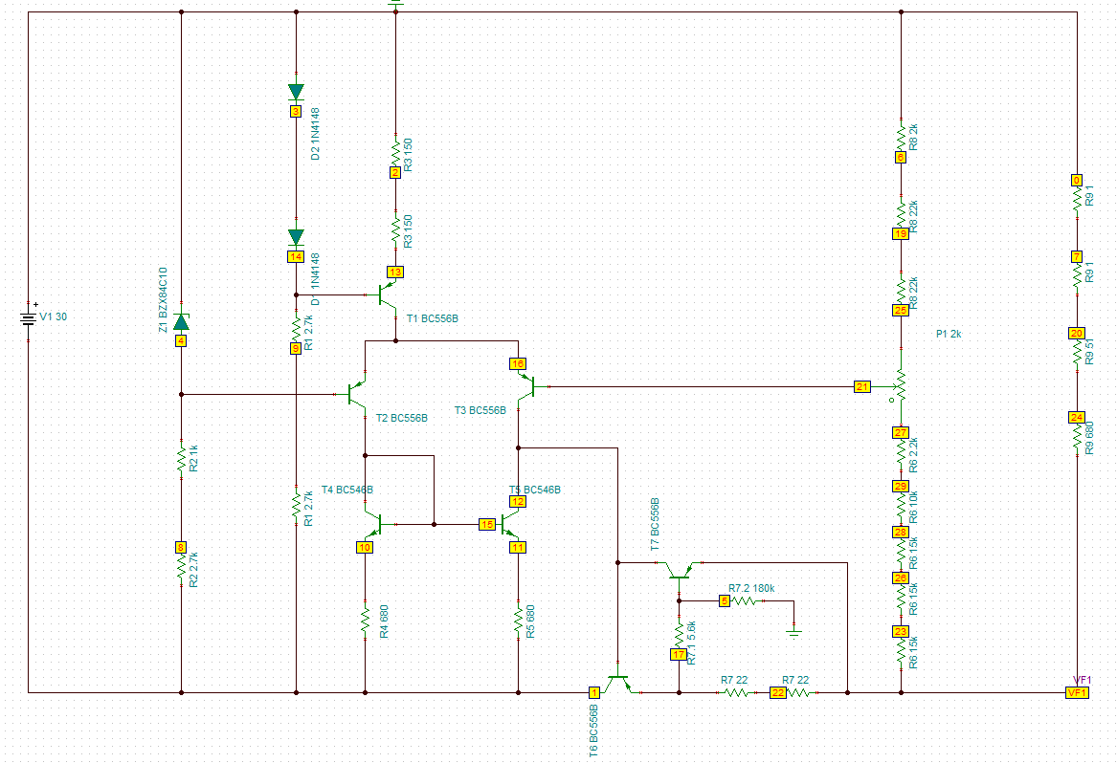

This section consists of a Zener diode, a resistor designed to control the current passing through the diode, and a capacitor (UVR1H101MPD) responsible for filtering noise across the Zener diode.

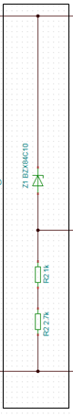

The current source is constructed using resistors along with transistor a Q8 and two diodes. Transistors Q1 and Q3 (BC856BLT1) facilitate current flow through the AD, while transistors Q6 and Q7 (BC546BBK) maintain emitter current balance.

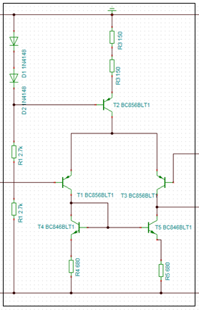

The RR consists of resistors R6 and R8 , along with potentiometer P1.



The purpose of the foldback current limiting circuit is to limit the output current in a controlled manner, providing protection to the circuit components and preventing damage in case of a short circuit or other overcurrent conditions.

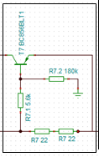

The transistor T6 drives the current towards the output.



**6.SPICE simulations of the designed circuit**

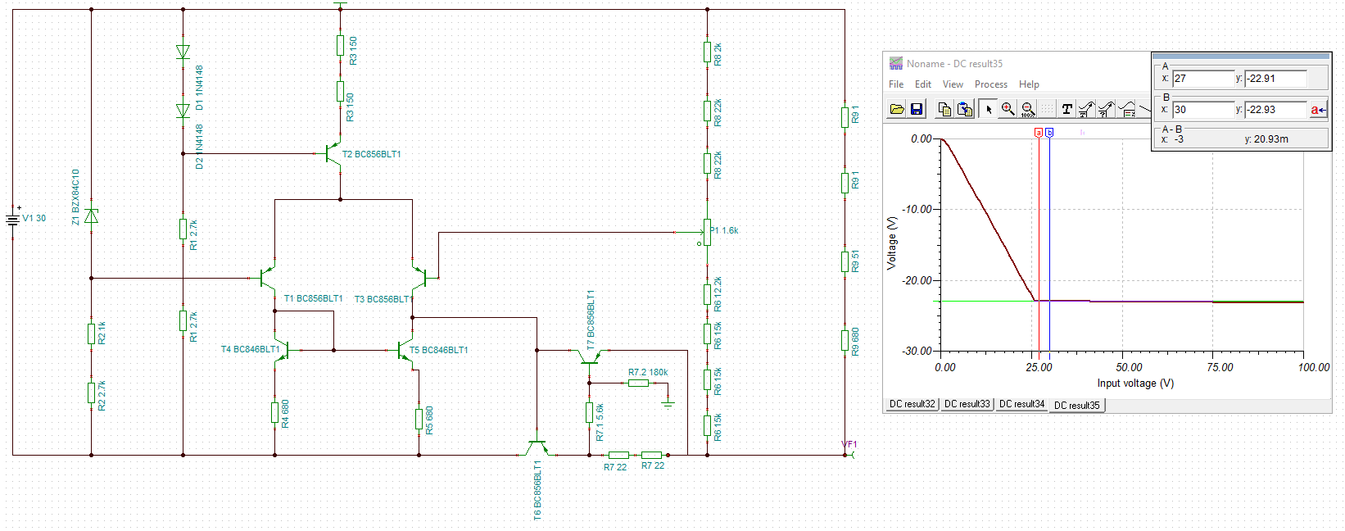

Above we have Voutmax present in optimal conditions with the potentiometer running at 2k, 0% setting and minimum input voltage

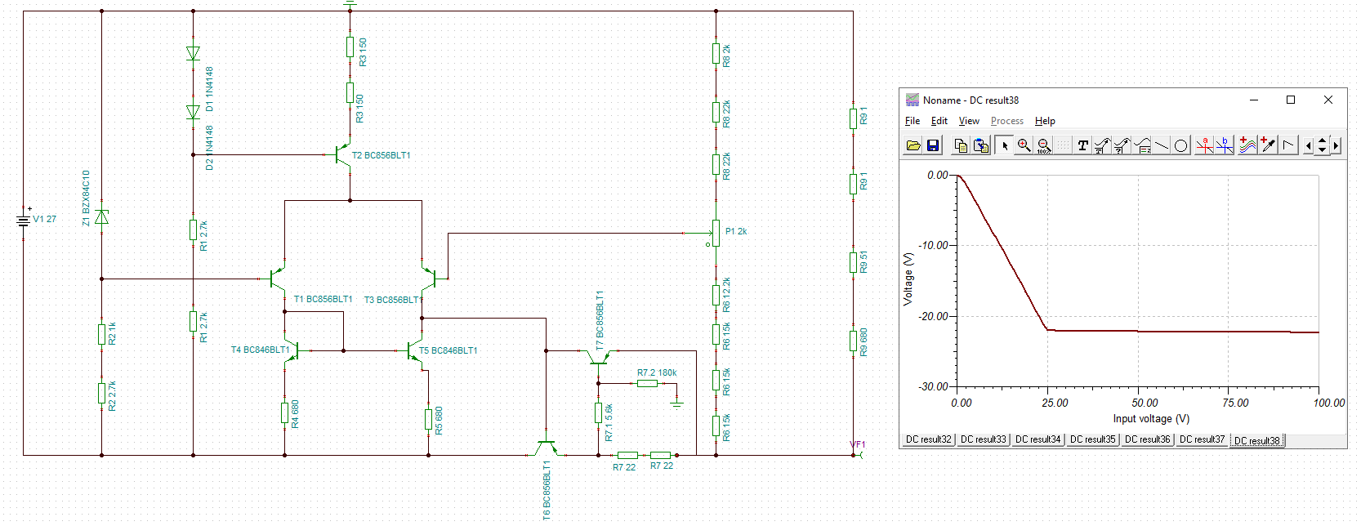

Above we have Voutmax present in optimal conditions with the potentiometer running at 2k, 0% setting and maximum input voltage

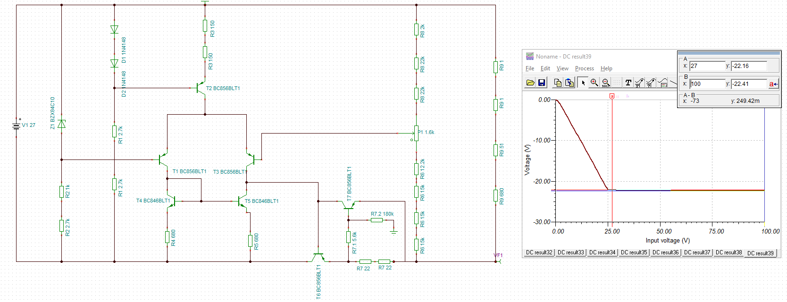

This is the worst case scenario running the potentiometer at 1.6k and 0% setting with maximum input voltage, and we can still see that it is very close to Voutmin



This is the worst case scenario running the potentiometer at 1.6k and 100% setting with minimum input voltage, and we can still see that it is very close to Voutmin

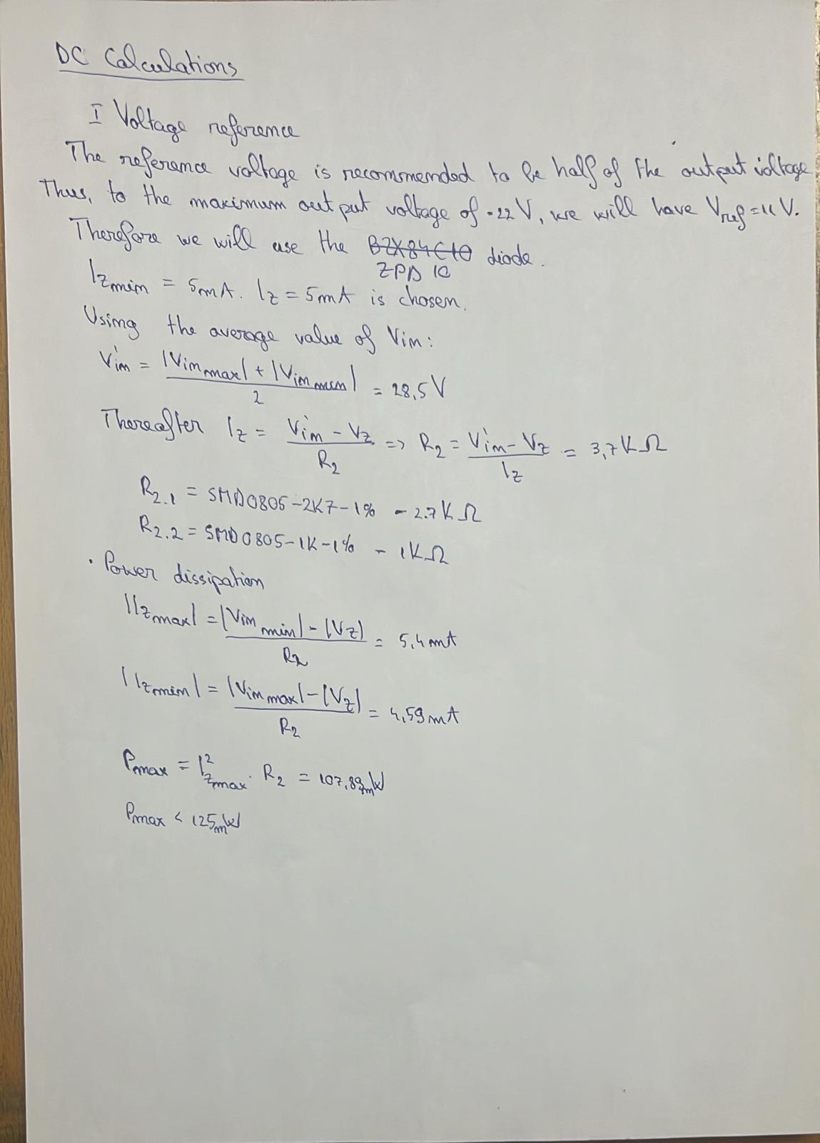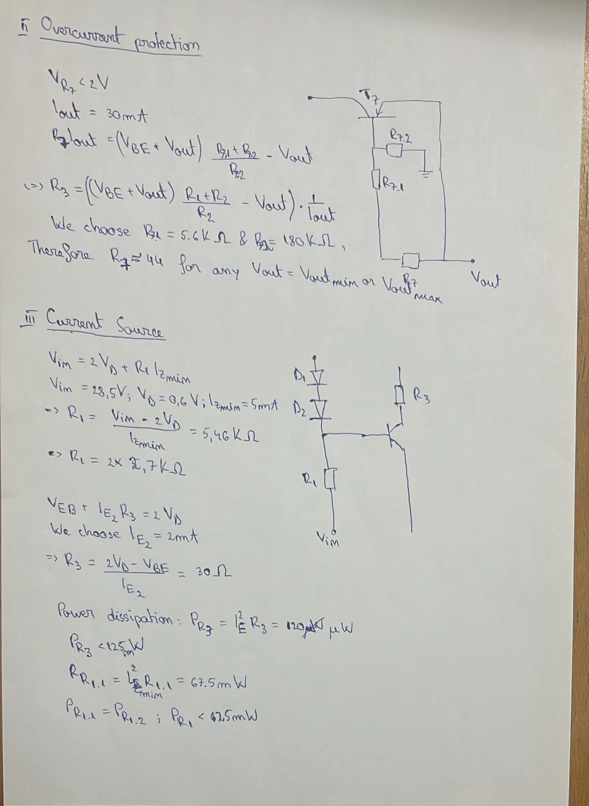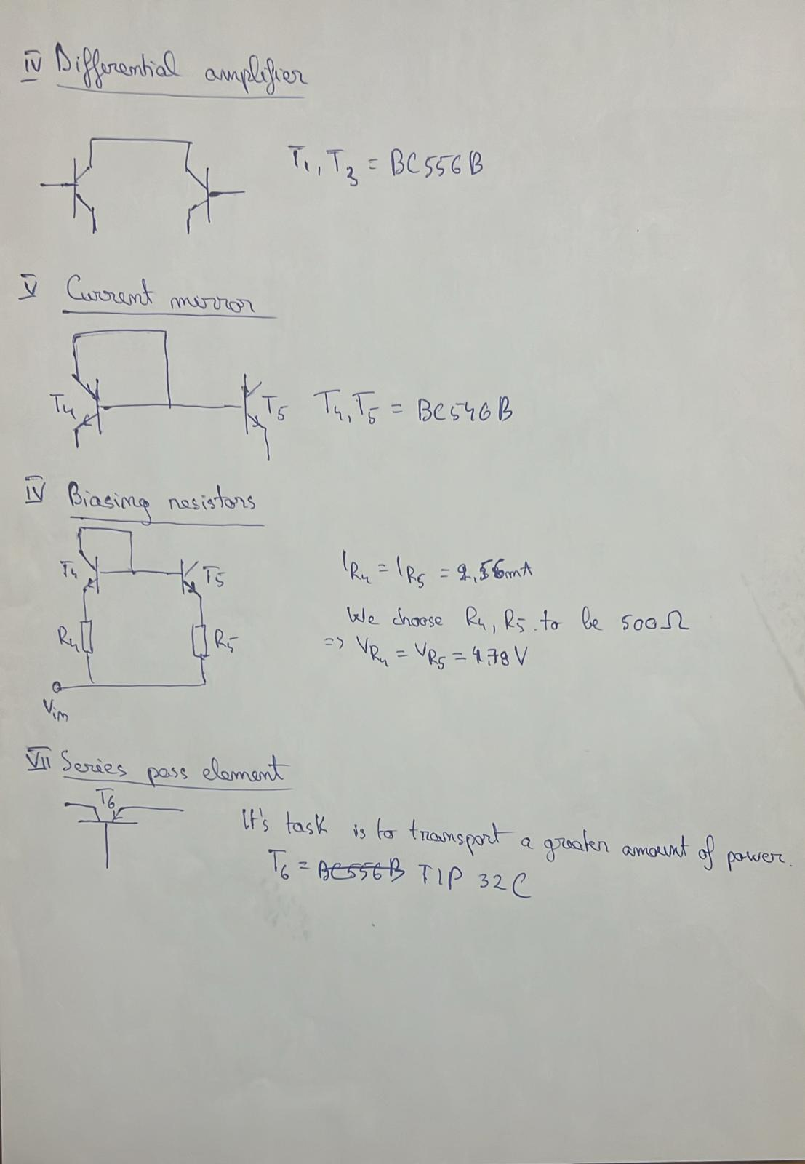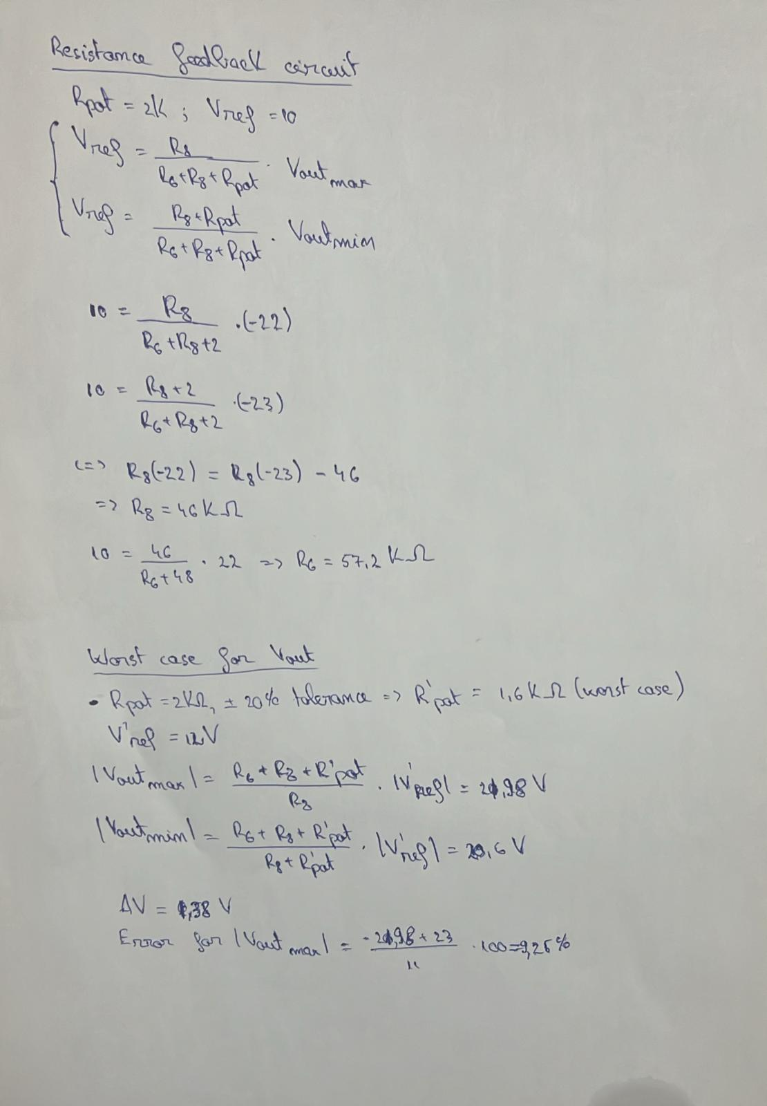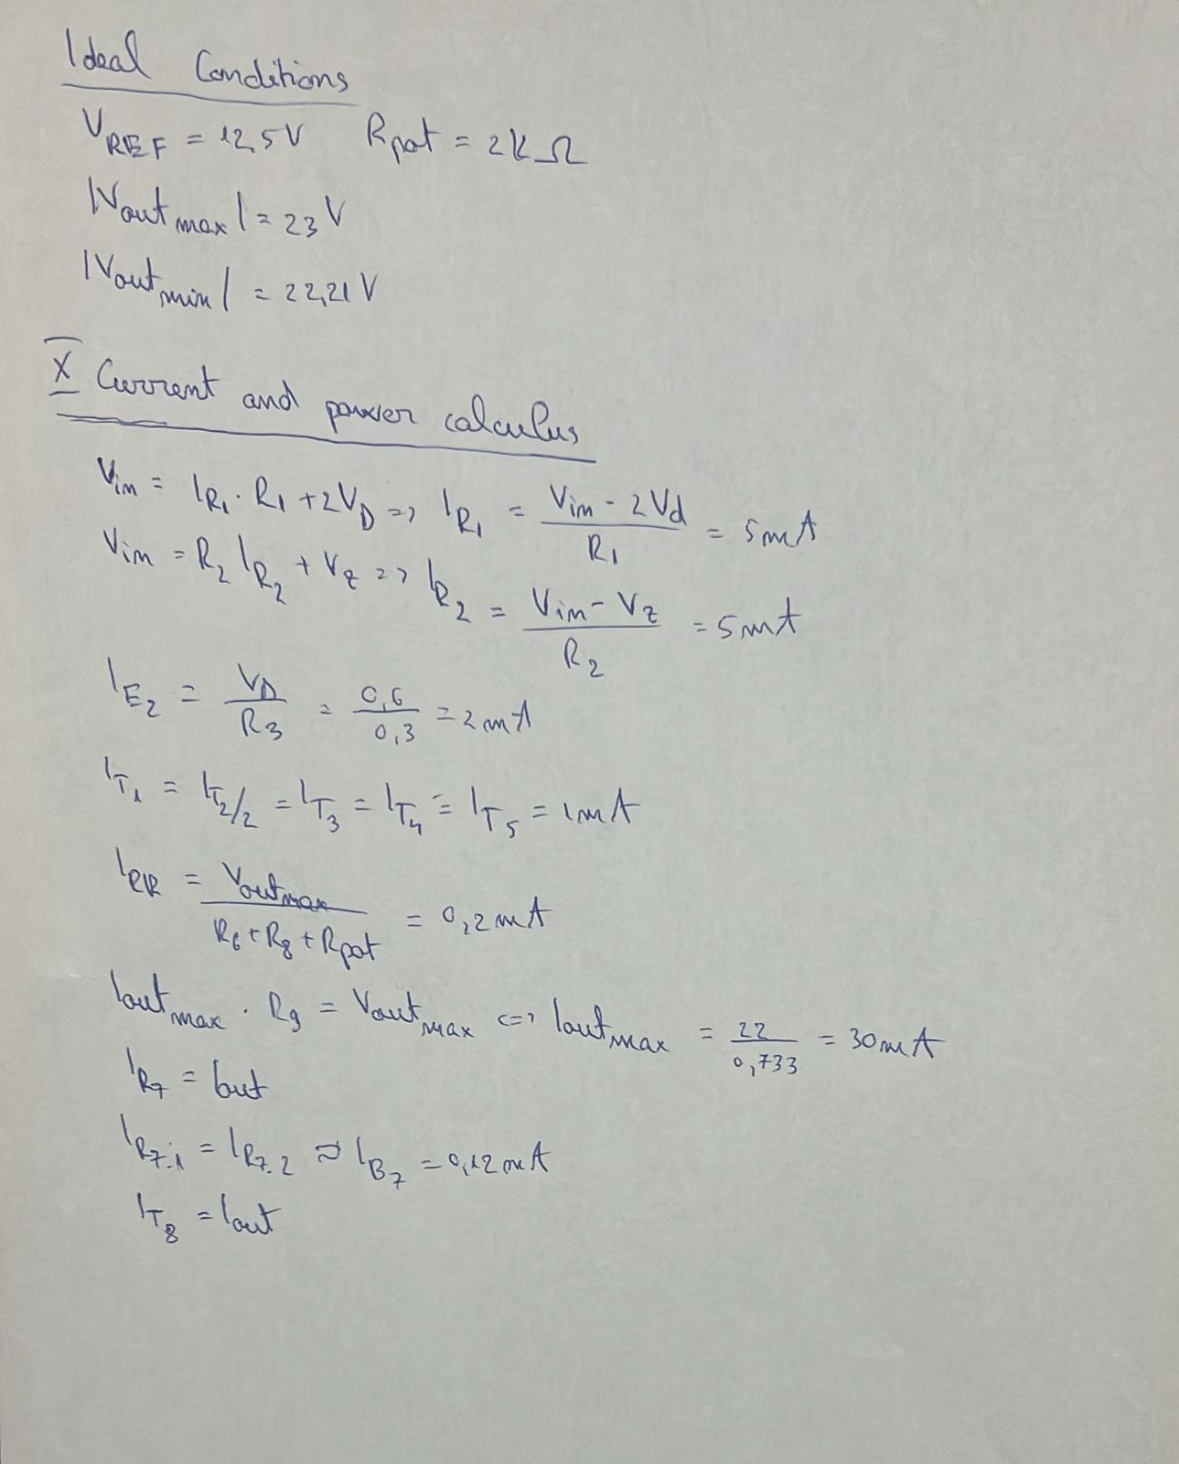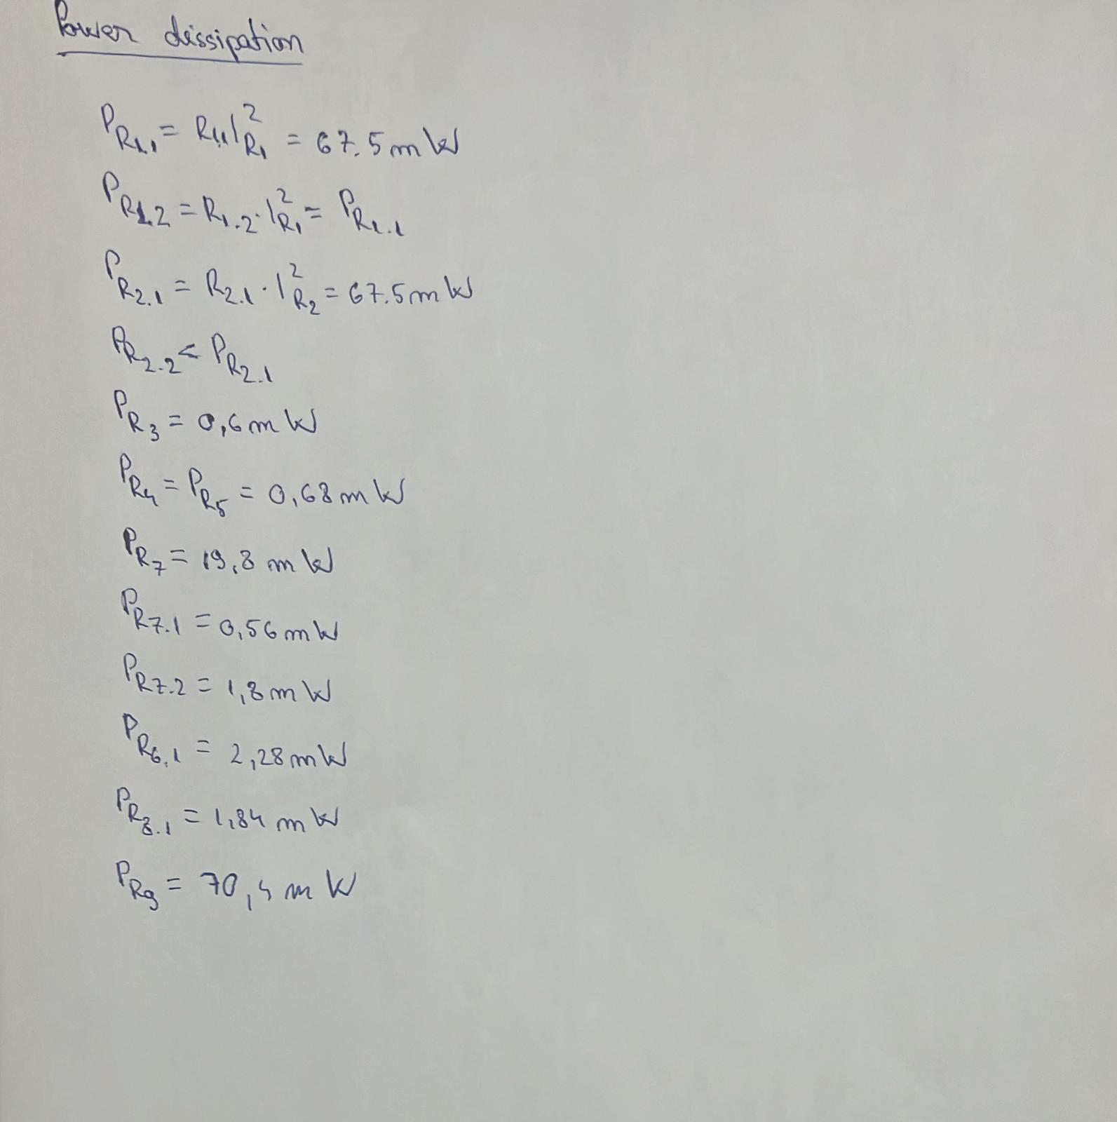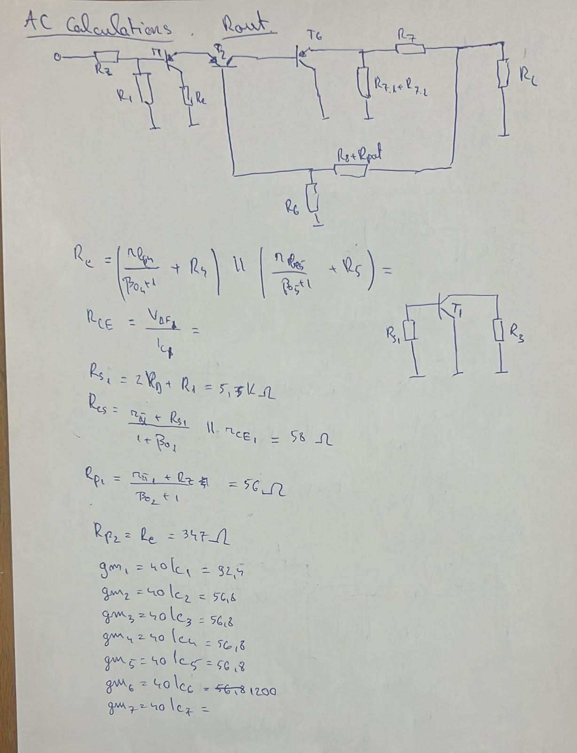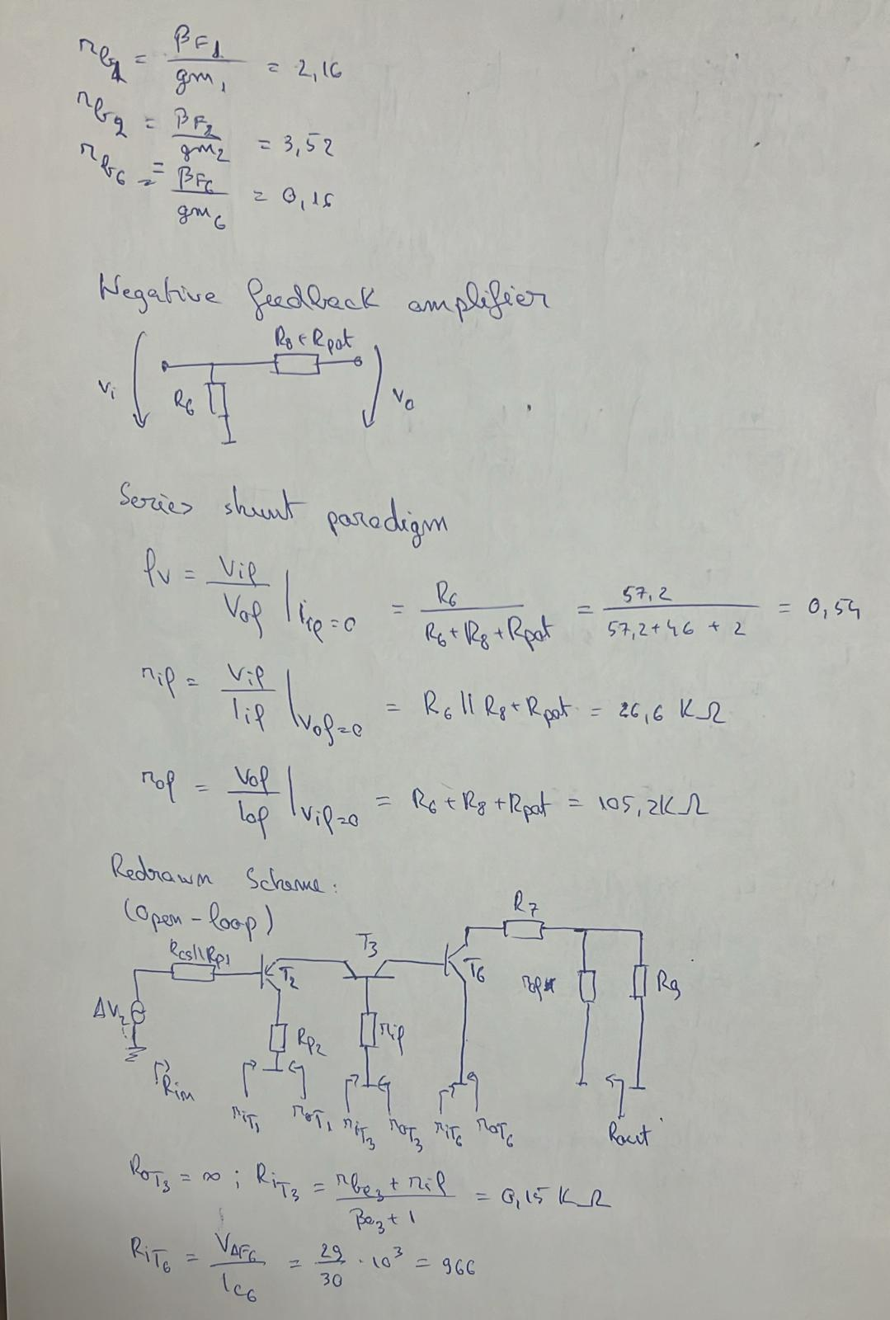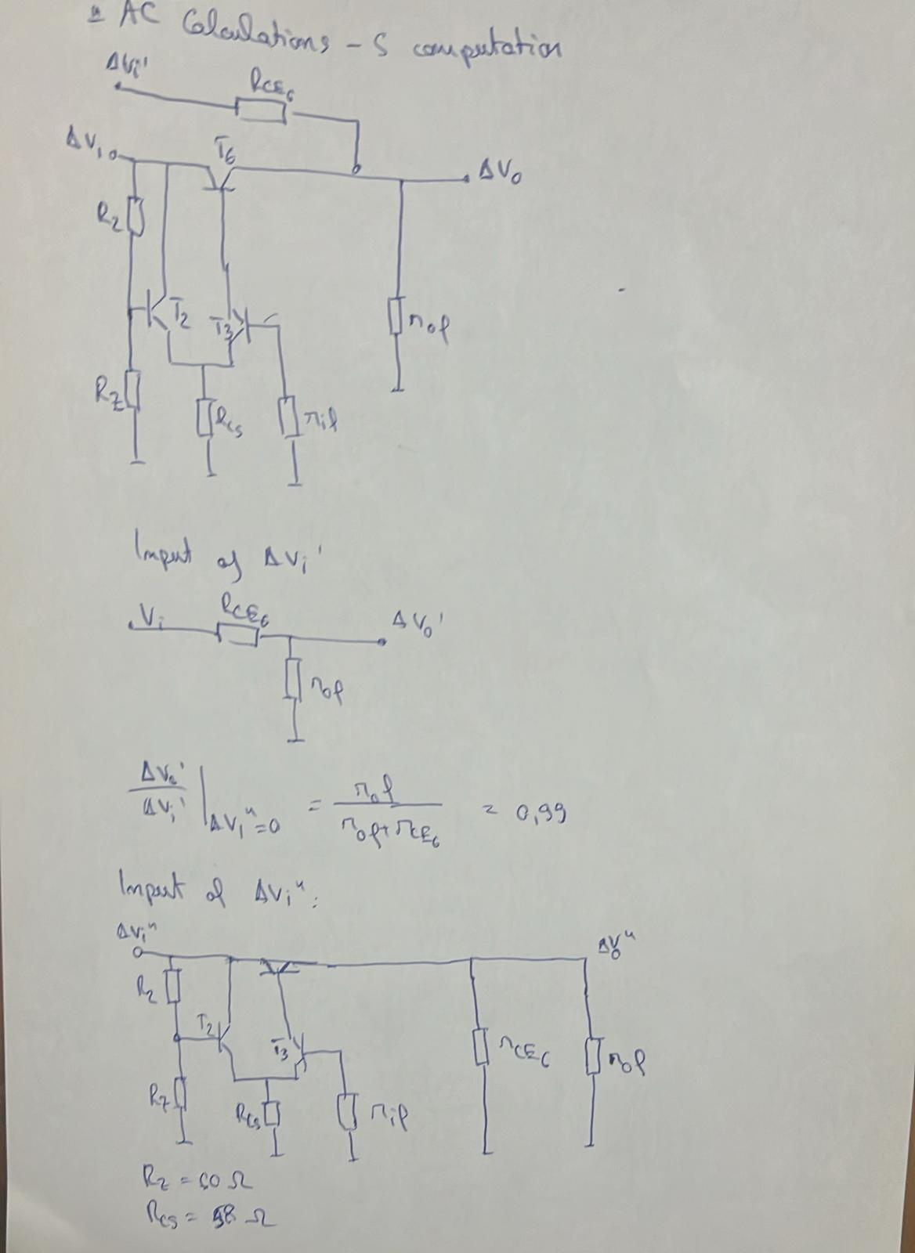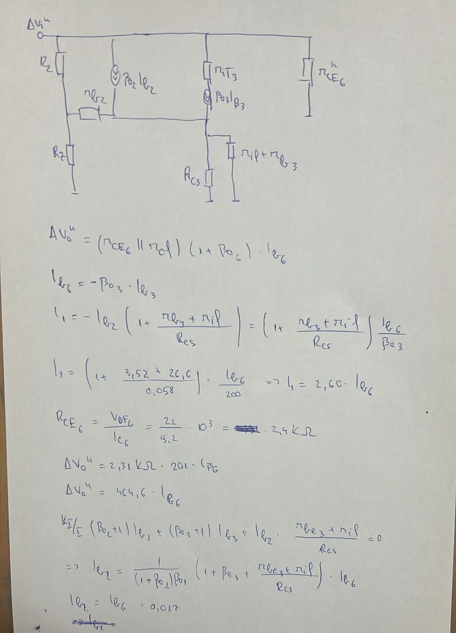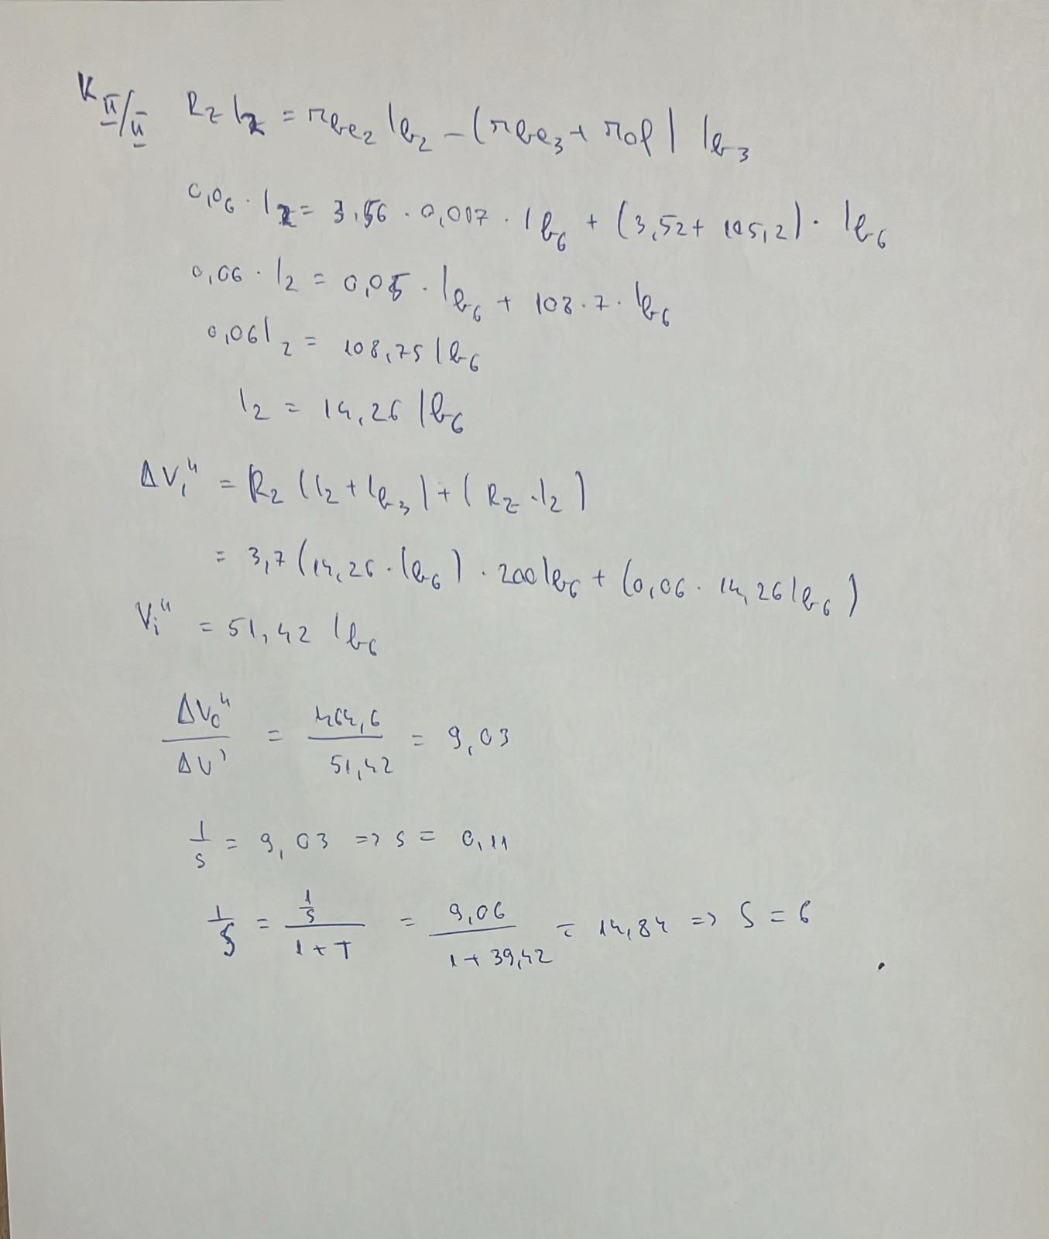

Av simulation

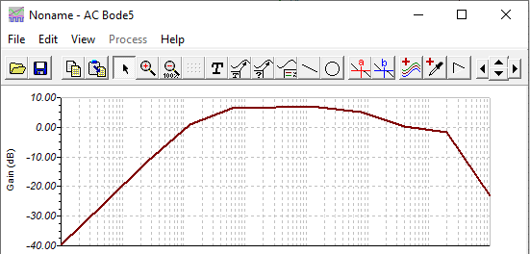

S simulation

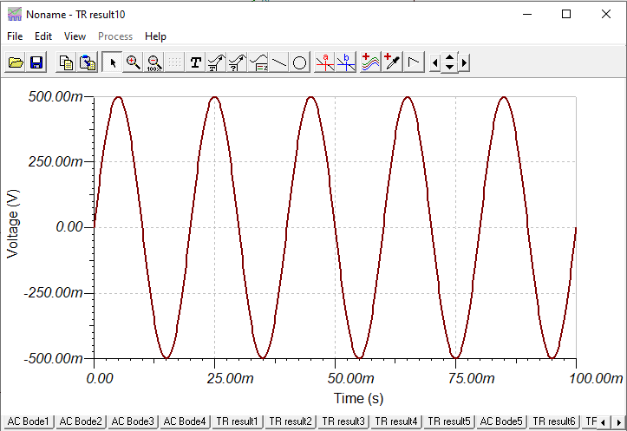

**7. Comments/Conclusions (max 1 page)**

Participating in this particular project has significantly contributed to enhancing my understanding of circuit design, offering me crucial insights into the intricacies of this field. I openly acknowledge that my grasp of electronics is somewhat limited, and this admission is the reason why I perceived the assigned task as moderately challenging. Despite the challenges, the experience proved exceptionally insightful for me, presenting an opportunity to broaden my knowledge base. I am optimistic about incorporating this newfound understanding into my upcoming projects, anticipating that it will serve as a valuable asset in shaping the outcomes of my future endeavors.

1. **Bill of Materials**

|  |  |  |  |  |  |  |  |  |  |
| --- | --- | --- | --- | --- | --- | --- | --- | --- | --- |
| Nr. Crt. | Nume | Catalog | Cod distrib | Nume prod | Prod | Clasă | Qty final | Descriere | **Distribuitor** |
| 1 | 1 | [**(LINK)**](https://www.tme.eu/ro/details/cf1_4w-1r/rezistente-carbon-tht-14w/sr-passives/) | THT; 1Ω; 0,25W; ±5% | CF1/4W-1R | SR PASSIVES | rezistor | 2 | Rezistor: de carbon; THT; 1Ω; 0,25W; ±5%; Ø2,3x6mm; Term: axial | **TME România** |
| 2 | 22 | [**(LINK)**](https://www.tme.eu/ro/details/cf1_4w-22r/rezistente-carbon-tht-14w/sr-passives/) | THT; 22Ω; 0,25W; ±5% | CF1/4W-22R | SR PASSIVES | rezistor | 2 | Rezistor: de carbon; THT; 22Ω; 0,25W; ±5%; Ø2,3x6mm; Term: axial | **TME România** |
| 3 | 51 | [**(LINK)**](https://www.tme.eu/ro/details/1_4w51r/rezistente-carbon-tht-14w/royal-ohm/cfrw4j0510a50/) | THT; 51Ω; 0,25W; ±5% | CFRW4J0510A50 | ROYAL OHM | rezistor | 1 | Rezistor: de carbon; THT; 51Ω; 0,25W; ±5%; Ø2,5x6,8mm | **TME România** |
| 4 | 150 | [**(LINK)**](https://www.tme.eu/ro/details/cf1_4w-150r/rezistente-carbon-tht-14w/sr-passives/) | THT; 150Ω; 0,25W; ±5% | CF1/4W-150R | SR PASSIVES | rezistor | 2 | Rezistor: de carbon; THT; 150Ω; 0,25W; ±5%; Ø2,3x6mm; Term: axial | **TME România** |
| 5 | 680 | [**(LINK)**](https://www.tme.eu/ro/details/cf1_4w-680r/rezistente-carbon-tht-14w/sr-passives/) | THT; 680Ω; 0,25W; ±5% | CF1/4W-680R | SR PASSIVES | rezistor | 3 | Rezistor: de carbon; THT; 680Ω; 0,25W; ±5%; Ø2,3x6mm; Term: axial | **TME România** |
| 6 | 1k | [**(LINK)**](https://www.tme.eu/ro/details/cf1_4w-1k/rezistente-carbon-tht-14w/sr-passives/) | THT; 1kΩ; 0,25W; ±5% | CF1/4W-1K | SR PASSIVES | rezistor | 1 | Rezistor: de carbon; THT; 1kΩ; 0,25W; ±5%; Ø2,3x6mm; Term: axial | **TME România** |
| 7 | 2k | [**(LINK)**](https://www.tme.eu/ro/details/cf1_4w-2k/rezistente-carbon-tht-14w/sr-passives/) | THT; 2kΩ; 0,25W; ±5% | CF1/4W-2K | SR PASSIVES | rezistor | 1 | Rezistor: de carbon; THT; 2kΩ; 0,25W; ±5%; Ø2,3x6mm; Term: axial | **TME România** |
| 8 | 2.2k | [**(LINK)**](https://www.tme.eu/ro/details/cf1_4w-2k2/rezistente-carbon-tht-14w/sr-passives/) | THT; 2,2kΩ; 0,25W; ±5% | CF1/4W-2K2 | SR PASSIVES | rezistor | 1 | Rezistor: de carbon; THT; 2,2kΩ; 0,25W; ±5%; Ø2,3x6mm; Term: axial | **TME România** |
| 9 | 2.7k | [**(LINK)**](https://www.tme.eu/ro/details/cf1_4w-2k7/rezistente-carbon-tht-14w/sr-passives/) | THT; 2,7kΩ; 0,25W; ±5% | CF1/4W-2K7 | SR PASSIVES | rezistor | 3 | Rezistor: de carbon; THT; 2,7kΩ; 0,25W; ±5%; Ø2,3x6mm; Term: axial | **TME România** |
| 10 | 5.6k | [**(LINK)**](https://www.tme.eu/ro/details/cf1_4w-5k6/rezistente-carbon-tht-14w/sr-passives/) | THT; 5,6kΩ; 0,25W; ±5% | CF1/4W-5K6 | SR PASSIVES | rezistor | 1 | Rezistor: de carbon; THT; 5,6kΩ; 0,25W; ±5%; Ø2,3x6mm; Term: axial | **TME România** |
| 11 | 10k | [**(LINK)**](https://www.tme.eu/ro/details/cf1_4w-10k/rezistente-carbon-tht-14w/sr-passives/) | THT; 10kΩ; 0,25W; ±5% | CF1/4W-10K | SR PASSIVES | rezistor | 1 | Rezistor: de carbon; THT; 10kΩ; 0,25W; ±5%; Ø2,3x6mm; Term: axial | **TME România** |
| 12 | 15k | [**(LINK)**](https://www.tme.eu/ro/details/cf1_4w-15k/rezistente-carbon-tht-14w/sr-passives/) | THT; 15kΩ; 0,25W; ±5% | CF1/4W-15K | SR PASSIVES | rezistor | 3 | Rezistor: de carbon; THT; 15kΩ; 0,25W; ±5%; Ø2,3x6mm; Term: axial | **TME România** |
| 13 | 22k | [**(LINK)**](https://www.tme.eu/ro/details/cf1_4w-22k/rezistente-carbon-tht-14w/sr-passives/) | THT; 22kΩ; 0,25W; ±5% | CF1/4W-22K | SR PASSIVES | rezistor | 2 | Rezistor: de carbon; THT; 22kΩ; 0,25W; ±5%; Ø2,3x6mm; Term: axial | **TME România** |
| 14 | 180k | [**(LINK)**](https://www.tme.eu/ro/details/cf1_4w-180k/rezistente-carbon-tht-14w/sr-passives/) | THT; 180kΩ; 0,25W; ±5% | CF1/4W-180K | SR PASSIVES | rezistor | 1 | Rezistor: de carbon; THT; 180kΩ; 0,25W; ±5%; Ø2,3x6mm; Term: axial | **TME România** |
| 15 | 2k | [**(LINK)**](https://www.tme.eu/ro/details/t75r-2k/trimere-tht-cu-o-singura-tura/sr-passives/) | T75R-2K | T75R-2K | SR PASSIVES | potențiometru | 2 | Potenţiometru: de montare; singură tură, orizontal; 2kΩ; 250mW | **TME România** |
| 16 | 10pF | [**(LINK)**](https://www.tme.eu/ro/details/cck-10p/condensatoare-ceramice-tht-100v/sr-passives/) | CCK-10P | CCK-10P | SR PASSIVES | condensator | 1 | Condensator: ceramic; 10pF; 100V; C0G; ±5%; THT; 5mm | **TME România** |
| 17 | 4148 | [**(LINK)**](https://www.tme.eu/ro/details/1n4148-tap/diode-universale-tht/vishay/) | 1N4148-TAP | 1N4148-TAP | VISHAY | diodă pn | 2 | Diodă: comutaţie; THT; 100V; 300mA; Ambalaj: Ammo Pack; DO35 | **TME România** |
| 18 | 10V | [**(LINK)**](https://www.tme.eu/ro/details/zpd10-dio/diode-zener-tht/diotec-semiconductor/zpd10/) | ZPD10-DIO | ZPD10 | DIOTEC SEMICONDUCTOR | diodă Zener | 1 | Diodă: Zener; 0,5W; 10V; Ambalaj: Ammo Pack; DO35 | **TME România** |
| 19 | PNP | [**(LINK)**](https://www.tme.eu/ro/details/bc556bbk-dio/tranzistori-tht-pnp/diotec-semiconductor/bc556bbk/) | BC556BBK-DIO | BC556BBK | DIOTEC SEMICONDUCTOR | tranzistor bipolar | 7 | Tranzistor: PNP; bipolar; 65V; 100mA; 500mW; TO92 | **TME România** |

**9. Layout/mounting map**

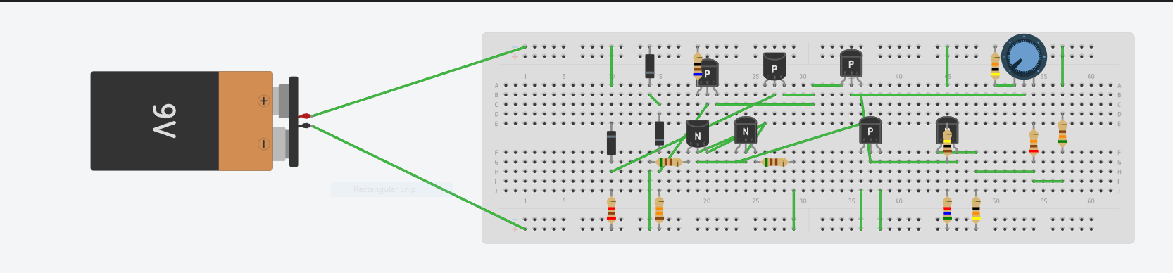

**10.Bibliography**

1. BC817 Datasheet: <https://www.diodes.com/assets/Datasheets/ds11107.pdf>
2. BC807 Datasheet: <https://www.diodes.com/assets/Datasheets/BC807-16_-25_-40.pdf> BZX84C5V6, BZX84C5V1, BZX84C10
3. Datasheet: <https://ro.mouser.com/datasheet/2/115/ds18001-1493999.pdf>
4. 1N4148 datasheet: <https://www.tme.eu/Document/8a0f4bd1d0e0495ebb1834ba060fbfa0/CD4148.pdf>
5. Power Transistor MJD31CG Datasheet: <https://www.tme.eu/Document/4b521f5243f7531696a0dc4af2c14260/MJD31_MJD32.pdf>
6. CEF courses about linear feedback voltage regulators with protection circuit for overvoltage and foldback overcurrent protection: <https://archive.curs.upb.ro/2021/pluginfile.php/185483/course/section/175622/5.6%20> Feedback%20regulators.pdf
7. Voltage regulator Example circuit: <https://wiki.dcae.pub.ro/images/5/51/Stabilizator.pdf>